VIP Cloud 1.0
Design Document

Document Authors:
Jimmy Liang
Jimmy Liang/US/VoiceRite

Table of Contents

I. Approvers 2
II. Change and Review Procedure 3
1 About This Document 5
1.1 Purpose 5
1.2 Intended Audience 5
2 Overview 5
3 Architecture 5
3.1 Diagram 5
3.1.1 VIP High Level Architecture 5
3.1.2 VIP Telephony Architect 6
3.1.3 VIP Server Architect 6
3.2 Components 7
3.2.1 Telephony 7
3.2.2 VIP Server 7
3.2.3 VIP Services 7
3.2.4 VIP Application 7
4 VIP Service APIs 7
4.1 Call Routing Service API 7
4.2 Application Service API 7
4.3 Account/Provisioning Service API 7
4.4 Media Service API 8
4.5 Name Resolution API 8
4.6 VRPN API 8

Document Control Information

Approvers
The following are members of the review team for this document. It is the document owner’s responsibility to poll the members for final approval of this document. By signing below, I am indicating that I have reviewed and approved this document.

Role | Name | Date | Signature | Comment
Owner | Joshua Schrager | -------------------- | --------------------
Project Manager | Jeff Engle | -------------------- | --------------------
Customer Support | Sajeev Ravi | -------------------- | --------------------
Product Manager | Steve Glickman | -------------------- | --------------------
Dev | Jimmy Liang | -------------------- | --------------------
AP Geo | Marc Russell | -------------------- | --------------------
UK Geo | Grace Jeffery | -------------------- | --------------------

Change and Review Procedure
To request changes to this document, notify the document owner(s) listed on the front page. The owner(s) of this document will have update authority. Changes not related to content (such as spelling, grammar, organizational title changes, etc.) do not require approval. When changes warrant a revision to this document, the changed draft document is made available for review and approval by approvers of this document. After comments and issues are addressed and resolved, the document is approved and the new version is made available.

Version | Date | Explanation
Draft 1.0 | 08/01/2012 | Create the document initially
- About This Document

Purpose
The purpose of this document is to outline and describe the design of VoiceRite Verizon Integration Partner (VIP) Cloud 1.0.

Intended Audience
The primary audience for this document includes, but is not limited to:
The members of the Executive Team
The Technical Teams
Marketing, Sales, Services and Support Teams

- Overview
VoiceRite Cloud 1.0 is the service API platform for application developers & resellers called Vz Integration Partners “VIPs” who drive Vz sales thru building & selling a new breed of real-time telecom applications.

Verizon will provide VoiceRite with a secure SIP link to VoiceRite switch/SBC for the purpose of allowing 3rd party access through ViceRite Cloud Service APIs to call data & control, including mobile device provisioning, for integration with CRM, ERP, and other line-of-business apps.

- Architecture

Diagram

VIP High Level Architecture
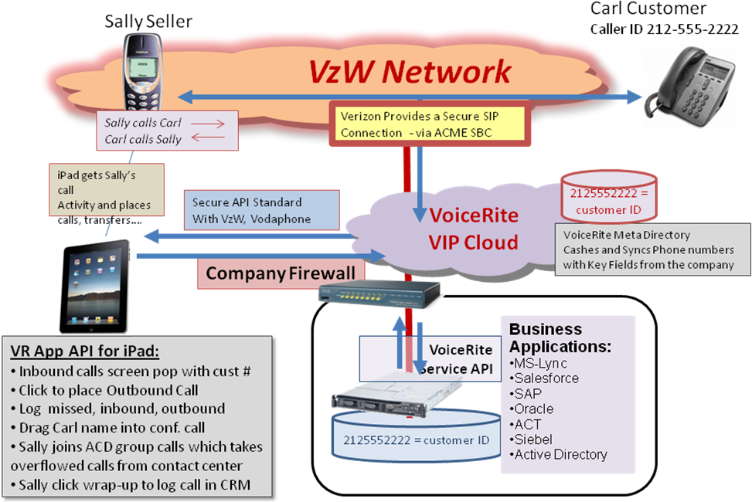

Description
Inbound call SIP signals from Verizon arrives at VoiceRite VIP cloud through the secure SIP links provided by Verizon. Our VIP Cloud (1) process SIP signal, (2) send the call data to registered 3rd parties applications, 3) convert the actions from 3rd party to SIP signals. The VIP cloud also provides services for 3rd party applications, for example, Name Resolution Service can look up caller information via various sources; Phone presence service provides phone availability and locations; Media services provides storage and access for media files etc.

3rd party application can make one or a batch of outbound calls via the Outbound service provided by VIP cloud. Not only the outbound call can connect to Verzion network, but also other telephony carries, SUT, UM, Skype or FreeTDM etc.

VIP cloud offers the ability for Verizon or 3rd party to monitor and analyze real time statistics, billing and daily/monthly call reports.

VIP Telephony Architect
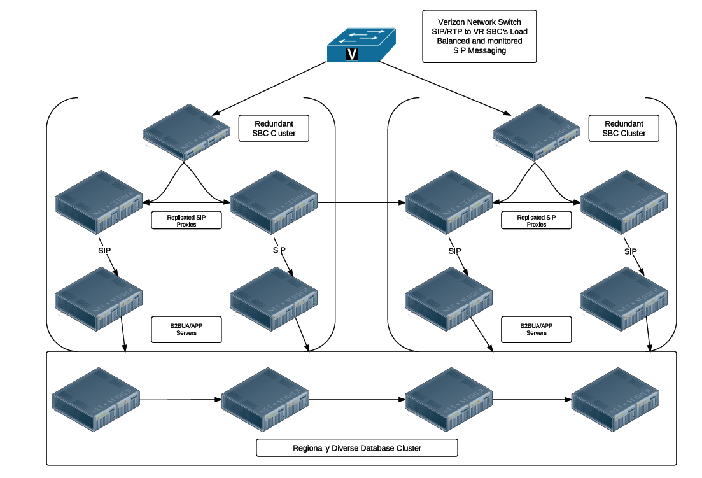

Description
Verizon network switches send SIP/RTP to VoiceRite SBC cluster load balanced. Redundant SBCs and SIP proxies allows VIP cloud to provide carrier grade services and availability. It provides high performance and no single point failure, continuous availability of active sessions.

VIP Server Architect

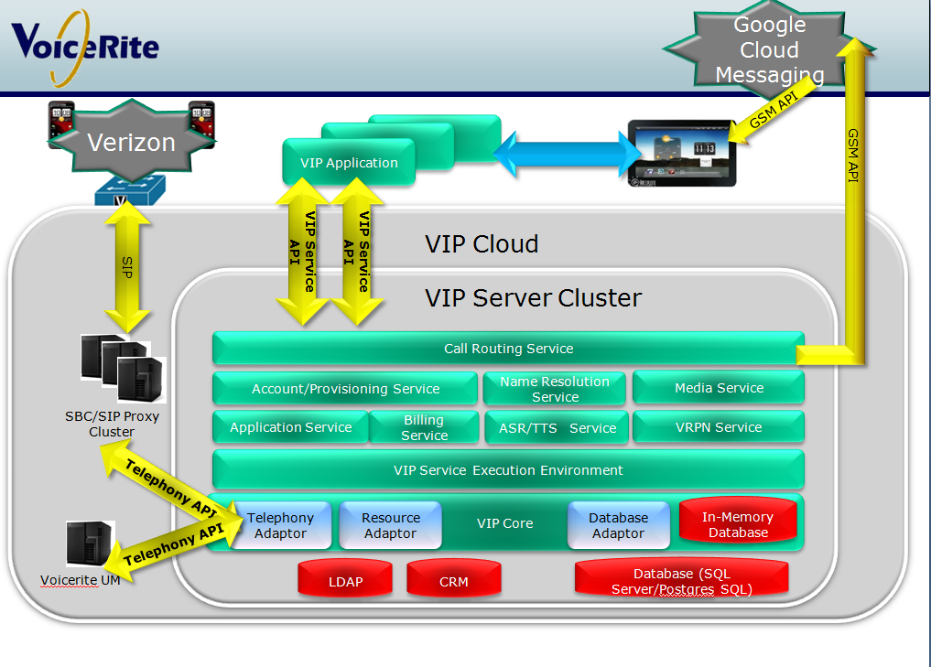

Description
The core component of the VIP cloud is the VIP server cluster which is which is designed and implemented for providing enterprise level and reusable services to 3rd party VIP applications. It also offers a center place for management, administration and reporting.

Components

Telephony

VIP Server

VIP Services

VIP Application

- VIP Service APIs

Call Routing Service API

Application Service API

Account/Provisioning Service API

Media Service API

Name Resolution API

VRPN API

